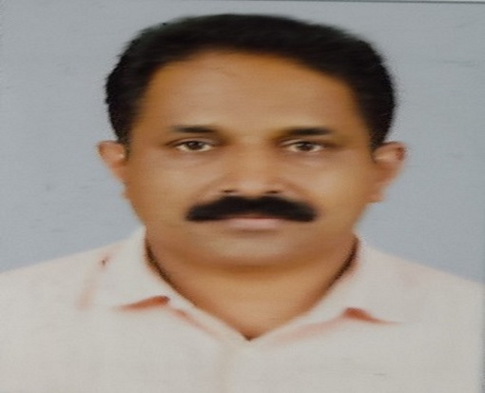
Dr.TomyK.O. M A (Eng.)M A (Pol.Science), M Sc ( Applied Psychology), M Ed, NET, PhD
Kuttickal house, Thirunelly,
Sulthan Bathery Post, Wayanad, Kerala
Pin-673592
bodhitom@gmail.com
9495176206
Twenty two years of Teaching,Training Experience, Counselling, Ph D in Neurocognitive Strategic Orientation
Professional Experience
St.Gregorios Teachers Training College, Meenangadi
Designation- Principal
Period- Since October 2020
Major Roles and Responsibilities
- Coordination of departmental activities
- Student mentoring
- Project assistance
- Trainer: B Ed Student Teachers
- Provide Research guidance
- Counseling
Mar Baselios College of Education, Sulthan Bathery
Designation- Assistant Professor of Education
Period- Since June 2012 to 2016 and 2019 December to October 2020
Major Roles and Responsibilities
- Student mentoring
- Project Assistance
- Leadership training for B Ed Student Teachers, Youth, Tribal students and parents
- Research guidance
Bharathidasan University, Thiruchirappalli
Designation- Research Scholar
Period –October2016 to November 2019
Research study titled “EFFECT OF NEUROCOGNITIVE STRATEGIC ORIENTATION
ONPERFPRMANCE STANDARDOF PANIYA TRIBAL STUDENTS”

- Research scholars’ coordinator
- Teaching M Ed students
- Research guidance for the M Phil students.

Sarath Pawar Public School, Kalwan, Nashik
Designation- Post graduate Teacher
Period-2000to 2006
Responsibilities
Boarding in Charge
HOD Social Science Department
Model Residential School Thirunelly,Wayanad, Kerala
Designation- Post graduate Teacher
Period-2010to 2011
Responsibilities
Boarding in Charge
HOD Social Science
Government Girls Higher Secondary School, B P Angadi, Tirur, Malappuram
Designation- Higher Secondary School Teacher
Period-2011to 2012

Educational Qualifications

2020 PhD in Education,
Department of Educational Tehnology,
Bharathidasan University, Thiruchirappalli.
2020 Master of Science in Applied Psychology,
Barathiar University
2013 NET (EDUCATION)
2010 -Master of Education
Mahathma Gandhi University, Kottayam, Kerala
2005 -Master of Arts, Annamalai University, Chidambaram, Tamilnadu
1998 -Master of Arts University of Calicut
2008 -Bachelor of Education,University of Calicut
1994- Bachelor of Arts Degree in Political Science
1990 -Pre Degree Course, University of Calicut
1988 -Secondary School Leaving Certificate(S.S.L.C),
Board of Public Examination, Kerala
Government High School, Noolpuzha, Wayanad, Kerala.
Tribal Initiative For Developmental Initiative
Designation- Programme co ordinator in TUDI Eachome
Period- 2006 to 2007
Responsibilities- Leadership Training, Tuition, Paniya Language Book Publication
Bodhi
Designation- Programme coordinator
Period-Since 2007
Responsibilities- Leadership Training, Tuition, Paniya Tribal Initiative Book Publication

Books Published

Dr. Tomy and Mr.Sarathkumar P. (2020). Fundamentals of Assessment for Learning, Eye books Kerala
Dr.Tomy Kuttickal Ouseph (2022) Educational Perspectives of Paniya Tribal Community, Archers & Elevators Publishing House, ISBN: 978-81-19653-56-0
Dr. Tomy Kuttickal Ouseph (2024). Exploring the NeurocognitiveFoundations of Mindful Educationwithin the Framework of the National Education Policy, 2020, Archers & Elevators Publishing House, ISBN 9781234567897

Articles Published
- Tomy K.O., Amutha S. (2019). Effect of Neurocognitive Strategy on Social Health of Paniya Tribal Students. INFOKARA RESEARCH, (8) 10, 229-239.
- Tomy K.O., Amutha S. (2019). Behavioral Inhibition of Paniya Tribal Students. Journal of Information and Computational Science, (9) 9, 550-560.
- Tomy K.O., Amutha S. (2019). Effect Of Orientation In Neurocognitive Strategies On Cultural Competency Of Paniya Tribal Studentsissn, (8) 8 2249-894X
- Tomy K.O., Amutha S. (2018). Effect of Orientation in Neurocognitive Strategies on the Performance standard of Paniya Tribal Students’ School Milieu, JETIR,(6) 6 ,2349-5162
- Tomy K.O., Amutha S.(2017). Multilingual freedom for Paniya tribal students
- Neurocognitive based instruction and cognitive improvement of specially abled students,BDU Educational Technology
- Tomy K.O., Amutha S.(2018). Neurocognitive instruction for attaining global standards
- Tomy K.O., Amutha S.(2017). Importance of neurocognitive orientation to the educator
- Tomy K.O., Amutha S.(2018). Neurocognitivesexual orientation strategy and academic performance of paniya tribal students
- Tomy K.O. (2017). Influence Of Mental Health On Academic Performance Of Paniya Tribal Students. International Journal of Innovative Research & Studies,( 7) 11, 2319-9725
- Tomy K.O. (2017). Innovative Educational Practices of Bodhi and TUDI in bringing Educational Advancement of Paniya Tribal Students, International Journal of Academic Research and Development, ISSN: 2455-4197, www.academicsjournal.com, Volume 2; Issue 5; September 2017; Page No. 346-347
Organization of National and International Seminars
International Seminar on the Topic “Exploring the NeurocognitiveFoundations of Mindful Educationwithin the Framework of the National Education Policy, 2020”
Organization of National and International Workshops
International workshop on the Topic “MENTAL HEALH AWARENESS AND STRESS MANAGEMENT”

